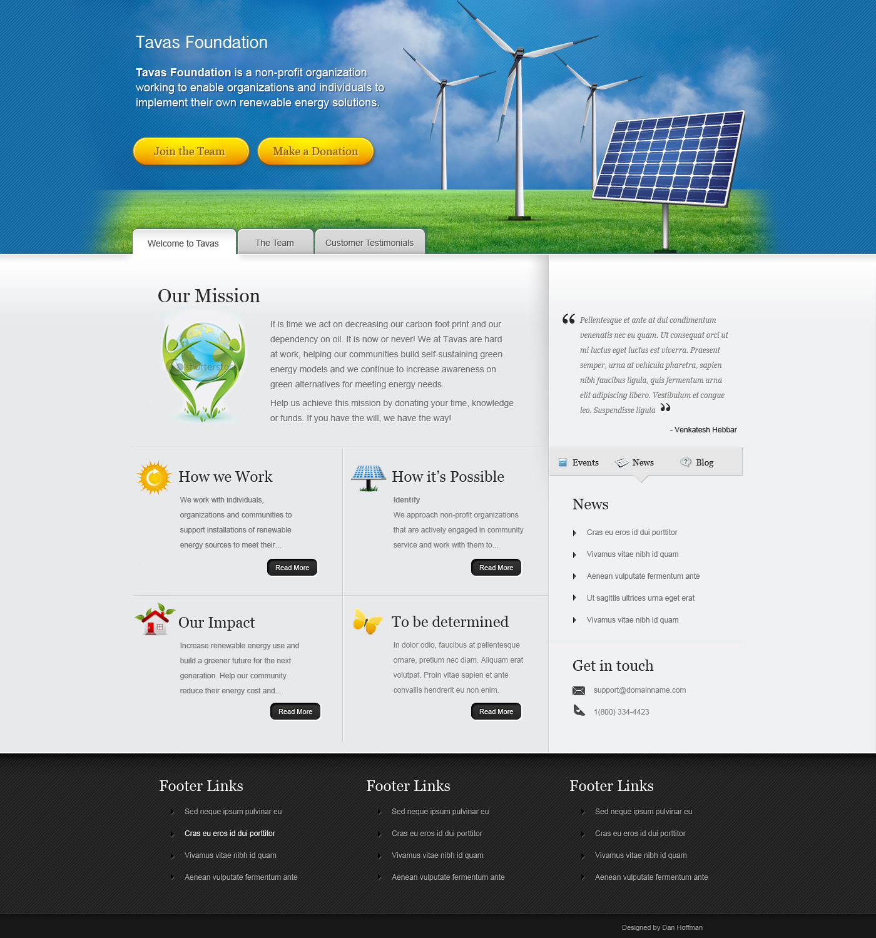

Tavas

It’s your power, own it!!

**Mission Statement:**

To empower communities and organizations to embrace cleaner energy alternatives through green energy installations.

**The Team:**

**Our Board Members:**

Co-Founder:

Noel’s passion is to conserve the planet for his children and grandchildren. The Tavas is the creation that allows Noel to funnel his own energy into changing how we power the planet, greener and cleaner. Noel has degrees in Civil Engineering and Information Systems and has a successful corporate career.

Co- Founder:

Venky Hebbar is a firm believer that the courage to dissolve a crisis situation lies in every individual. Increasing dependency on foreign oil and the subsequent devastation that this resulted in during the gulf oil crisis strengthened his belief in alternative energy sources as an absolute solution. This belief led him to co-found Tavas.

Venky holds an MS in Computer Science and has a successful corporate career.

**Our Friends/Volunteers:**

**How we work:**

**Step 1 – Identify Needs:**

We help organizations and communities to be self reliant for their energy requirements by funding and supporting them on their path to oil-independence through alternative energy source installations. Our experts analyze consumption patterns before recommending the best energy solution fit. Alternate energy solution options may include wind, solar or geo-thermal energy sources.

**Step 2 – Approach Retailers/Manufacturers**

Best bids are selected through responses to RFPs in the local market. Vendors participating in the RFP process are considered only after extensive research on company background, company reputation, cost factors, infrastructure, referrals, and reliability. Tavas works with each manufacturer and retailer to ensure best pricing for our valued customers.

**Step 3 – Fund Projects**

Tavas helps its customers to fund their energy installation projects through voluntary and government based grants. Based on individual installations, partial to full funding may be obtained. The borrowed amount is repaid to Tavas without interest, over time. Tavas reinvests these funds in not-for-profit installation projects.

Our Vision -

**Define Current Problem:**

**How Tavas Helps solve this problem**